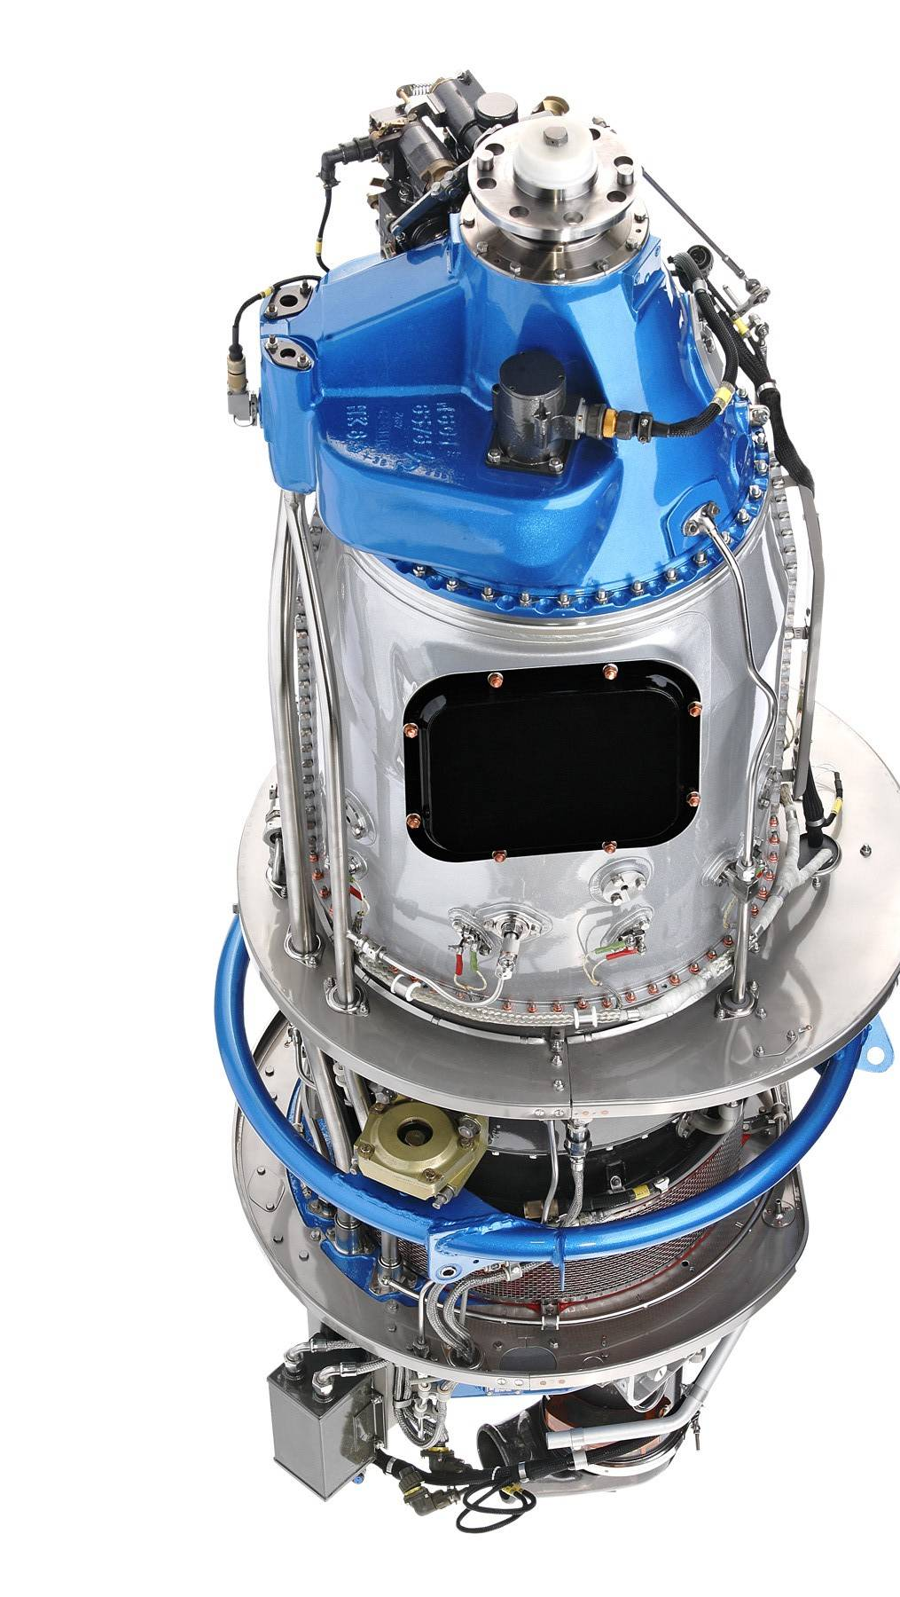
GE Aviation Czech
Reliability Trainee vacancy

We are looking for students who are keen to work in the aerospace industry

GE Aviation Czech is the only company in the Czech Republic to develop, manufacture and sell turboprops engines. GE Aviation Czech continues in the tradition of Walter, Czech engine manufacturer. Being a GE division we are a fully qualified and EASA certified aircraft design, manufacture and service organization. The development focuses on new engines as well as innovation of present models.

Role Summary:
The Trainee Reliability Analyst will work within Reliability team and will be responsible for developing / performing reliability analysis using approved aviation industry methods.

We require: Student of 4th or 5th year of mathematics or statistics, technical mindset, independence, interest in the aerospace industry, advanced knowledge of English

We offer: Attractive remuneration, working at a large international company, employee benefits, possibility of full-time employment in after completion of studies

Term: definite
Working hours: up to 20 hours/week
Availability: immediate


Send your CV to gabriela.hlavicova@ge.com, contact person Gabriela Hlavicová (HR Specialist, tel: +420 222 538 934).

